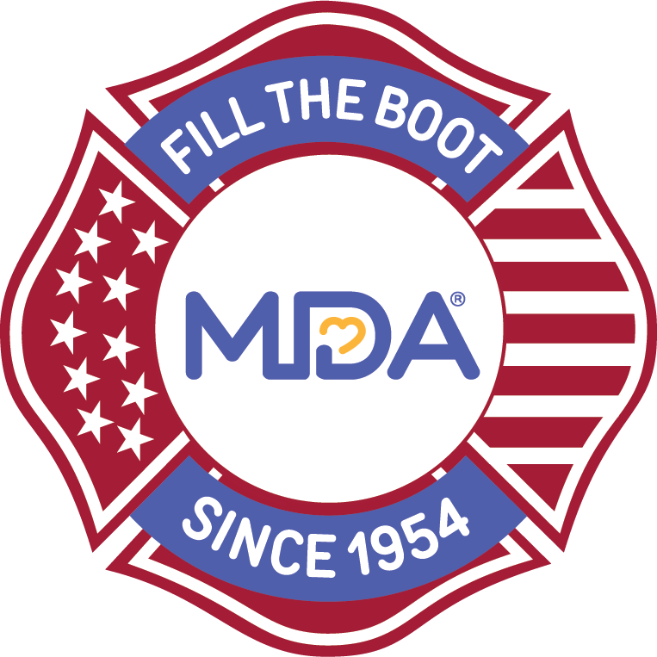

Contact: [Local MDA Name]
[Local MDA Title]
[Local MDA Phone]
[Local MDA Email]

MDA Partners with [City] Fire Fighters to

Kick Off Annual Fill the Boot Campaign

Fill the Boot drives benefitting kids and adults with muscular dystrophy begin [Date(s)]
[CITY (ALL CAPS)], [State], [Month] [Day], 2023 — A special kickoff event for the annual Fill the Boot drive is being hosted by members of the [Fire Department name and/or Professional Fire Fighters Association Local ##], along with the Muscular Dystrophy Association (MDA), to raise critical funds to empower families living with muscular dystrophy, ALS, and related neuromuscular diseases to live longer, more independent lives

The kick-off event on [Date] at [Location] continues this honored [IAFF/ fire fighter] tradition after almost 70 years of dedicating their time to support research, care, and advocacy for families in our community living with muscular dystrophy, ALS and related neuromuscular diseases
[Insert specific kickoff event activities here. Include spokespeople and speakers, additional partners, MDA families and local notable VIPs that will be in attendance].
“The members of the [Fire Department name and/or Professional Fire Fighters Association Local ##] display an unwavering support for MDA as they raise funds to support families living with neuromuscular disease locally and across the country,” said [MDA Title] [Name]. “We are so excited to kick off 2023 Fill the Boot drives with these first-responders who mirror the strength of MDA families.”

On [Today/Date] at [Time], this year’s Fill the Boot drive will officially begin at [FTB location(s)]. More than [number] members of the [Fire Department name and/or Professional Fire Fighters Association Local ##] will greet [motorists on the street/ shoppers and others outside the store] all over the city, asking them to donate to help MDA lead the way in accelerating research, advancing care, and advocating for the support of our families.

Donations from the 2023 [City] Fill the Boot drive support ground-breaking research and care at some of the largest nationwide network of multidisciplinary Care Centers including [insert local care center]. They also support MDA Summer Camp, where kids 8-17 develop life-long skills, friendships, confidence, and independence – all at no cost to their families.

MDA and IAFF Partnership
The partnership between the IAFF and MDA began in 1954 when the organization committed by proclamation to support MDA until a cure is found, and the organization's unwavering commitment to MDA has remained strong to this day. As MDA’s largest national partner, they have raised more than $690 million for MDA to date. Today the IAFF and MDA partnership is working to expand newborn screenings in the U.S. with Pompe disease and Spinal Muscular Atrophy (SMA) so that every child begins receiving the right treatment and is connected with expert clinical care as soon as possible to drive the best possible health outcomes.

About the IAFF
The International Association of Fire Fighters represents more than 334,000 full-time professional fire fighters and paramedics in more than 3,500 affiliates. IAFF members protect more than 85 percent of the population in communities throughout the United States and Canada.
About Muscular Dystrophy Association
Muscular Dystrophy Association (MDA) is the #1 voluntary health organization in the United States for people living with muscular dystrophy, ALS, and related neuromuscular diseases. For over 70 years, MDA has led the way in accelerating research, advancing care, and advocating for the support of our families. MDA’s mission is to empower the people we serve to live longer, more independent lives. To learn more visit mda.org and follow MDA on Instagram, Facebook, Twitter, TikTok, and LinkedIn.
- MDA -

