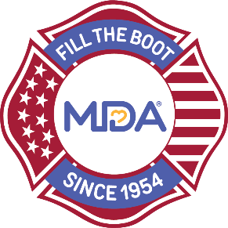
[City] Fill the Boot Media Kickoff Agenda
[Insert Date]
Time | Speaker | Agenda Items
3 minutes | President [Name] of [City] Fire Fighters Local [Number] AND/OR [City] Department Fire Chief [Name] | Opening Remarks
2 - 3 minutes | Whoever did not make the opening remarks should do this, the President or the Chief | Purpose of today’s event
2 minutes | Fill the Boot Coordinator [Name] | History of Fill the Boot:  [City & Local #]
2 minutes | Fill the Boot Coordinator or Local President & goal for this year | Announcement of 2023 Dates
2 minutes | Mayor [Name] of [City] or City Council member [Name] or both if they would both like to speak | Read the Proclamation & introduce local individual of family served by MDA
2-3 minutes | [Name of local individual or family served by MDA] | Comments & thank-you message
2-3 minutes | Local President | Closing Comments
Close | [Name of local individual or family served by MDA] passes the boot for first donations. | Pass the Boot
Photo Opportunity should include the Mayor and City Officials, the Fire Chief, the Local President, the Fill the Boot Coordinator, local individuals/families served by MDA in front of podium or apparatus (E.G., truck) with Fill the Boot banner.
Note: Aim to keep the entire event right around 30 minutes. At the end of the press conference, the Local President or Fill the Boot Coordinator, as well as local MDA representatives and individuals/families served by MDA, should be available for media interviews.

