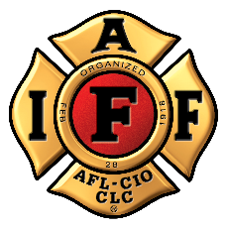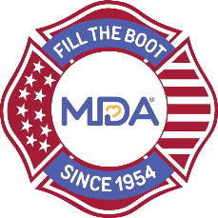
FOR IMMEDIATE RELEASE

Contact:
Contact Name
Contact Email
Contact Phone

[Professional Fire Fighters Association Local ##] [Launches/Join] Annual MDA Fill the Boot Campaign to Accelerate Research and Advance Care for Families Living with Muscular Dystrophy, ALS, and Related Neuromuscular Diseases in [City]

CITY (ALL CAPS), State, Month Day, Year — The International Association of Fire Fighters (IAFF) has collected critical funds in the community since 1954 – one dollar at a time – as part of the Fill the Boot program for the Muscular Dystrophy Association (MDA). The Professional Fire Fighters Association Local ## will continue this long-standing tradition as its members kick off the annual program raising funds to support MDA’s vision to accelerate research, advanced care, and advocate to empower families living with muscular dystrophy, ALS (aka Lou Gehrig’s disease), and related neuromuscular diseases in support of the families MDA serves.

Dedicated fire fighters from Professional Fire Fighters Association Local ## will hit the streets/storefronts with boots in hand asking pedestrians, motorists, customers, and other passersby to donate to MDA on Dates at Time, at FTB location(s).

The partnership between MDA and IAFF began in 1954 when the IAFF signed a proclamation designating MDA its charity of choice and vowing to continue raising awareness and funds until cures are found. To date, the nearly seven-decade partnership has raised more than $690 million with involvement from over 334,000 fire fighters nationwide. These funds have led in part to 19 FDA approved drugs for neuromuscular disease in the last 15 years with many more on the horizon. Those treatments are a reality today due to MDA’s vision, to build a new field of medicine in neuromuscular disease and push the boundaries of the medical frontier we call genetic medicine.

“For almost 70 years, the Muscular Dystrophy Association’s Fill the Boot campaign has raised critical funds for research and care for people who live with a neuromuscular disease and we are honored to be a part of their effort for this important mission,” said [Name], President of the Professional Fire Fighters Association Local ##.

For more information about Fill the Boot or to donate online, please visit: https://filltheboot.donordrive.com/URL
About the IAFF
The International Association of Fire Fighters represents more than 334,000 professional fire fighters and paramedics who protect 85% of the nation's population. More than 3,500 affiliates and their members protect communities in every state in the United States and in Canada. To learn more visit IAFF.org and follow the IAFF at Facebook, Twitter, and Instagram.

About Muscular Dystrophy Association
Muscular Dystrophy Association (MDA) is the #1 voluntary health organization in the United States for people living with muscular dystrophy, ALS, and related neuromuscular diseases. For over 70 years, MDA has led the way in accelerating research, advancing care, and advocating for the support of our families. MDA’s mission is to empower the people we serve to live longer, more independent lives. To learn more visit mda.org and follow MDA on Instagram, Facebook, Twitter, TikTok, and LinkedIn.
###

