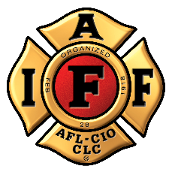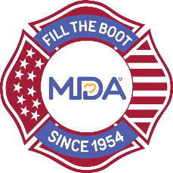
FOR IMMEDIATE RELEASE

Contact:
Contact Name
Contact Email
Contact Phone

$Amount Raised by City Fire Fighters During 2023 Fill the Boot Campaign to Support Muscular Dystrophy Association
CITY (ALL CAPS), State, Month Day, Year — During the 2023 Muscular Dystrophy Association (MDA) Fill the Boot campaign, the dedicated members of the Professional Fire Fighters Association Local ## took to the streets or store fronts and continued an almost 70-year tradition of raising funds to support MDA’s mission to accelerate research, advance care, and advocate for the support of families living with muscular dystrophy, ALS, and related neuromuscular diseases.

Insert your local FTB event information here, including locations, special activities you had, E.G. kick off events, etc.
“The fire fighters of Professional Fire Fighters Association Local ## have once again gone above and beyond for MDA’s families during this year’s Fill the Boot campaign,” said MDA Fire Fighter Partnership Rep. Title, Name. “We are so grateful for their dedication and for the generosity of those in the City community who have helped to raise critical funds for research and care.

In addition to Fill the Boot drives, fire fighter contributions from year-round local events, including if applicable, insert additional local events FFs participate in, E.G. softball tournaments, galas, golf tournaments, etc. help support MDA families.
Funds raised through City Fill the Boot events go towards groundbreaking research, life-enhancing educational programs, a resource center, and support for multi-disciplinary medical teams at the MDA Care Center at Hospital Name(s) in Location(s). They also help send more than Number local kids to a transformative experience at MDA Summer Camp - all at no cost to families.

Individuals and local businesses can still support the fire fighters by donating online at: https://filltheboot.donordrive.com/URL

About the MDA and IAFF Partnership
The partnership between MDA and the IAFF began in 1954 when the IAFF signed a proclamation designating MDA its charity of choice and vowing to continue raising awareness and funds until cures are found. To date, the nearly seven-decade partnership has raised more than $690 million with involvement from fire fighters nationwide. These funds have led in part to over a dozen FDA-approved drugs in as many years for those with neuromuscular disease. Those treatments were created from MDA’s vision to open a new field of medicine and push the boundaries of the medical frontier we call genetic medicine.

About the IAFF
The International Association of Fire Fighters represents more than 334,000 professional fire fighters and paramedics who protect more than 85% of the nation's population. More than 3,500 affiliates and their members protect communities in every state in the United States and in Canada. To learn more visit IAFF.org and follow the IAFF at Facebook, Twitter, and Instagram.

About Muscular Dystrophy Association
Muscular Dystrophy Association (MDA) is the #1 voluntary health organization in the United States for people living with muscular dystrophy, ALS, and related neuromuscular diseases. For over 70 years, MDA has led the way in accelerating research, advancing care, and advocating for the support of our families. MDA’s mission is to empower the people we serve to live longer, more independent lives. To learn more visit mda.org and follow MDA on Instagram, Facebook, Twitter, TikTok, and LinkedIn.
###

