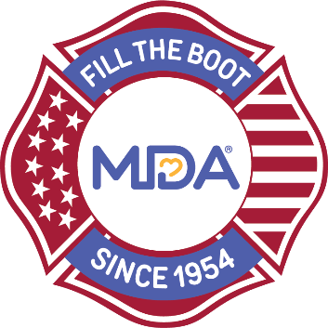
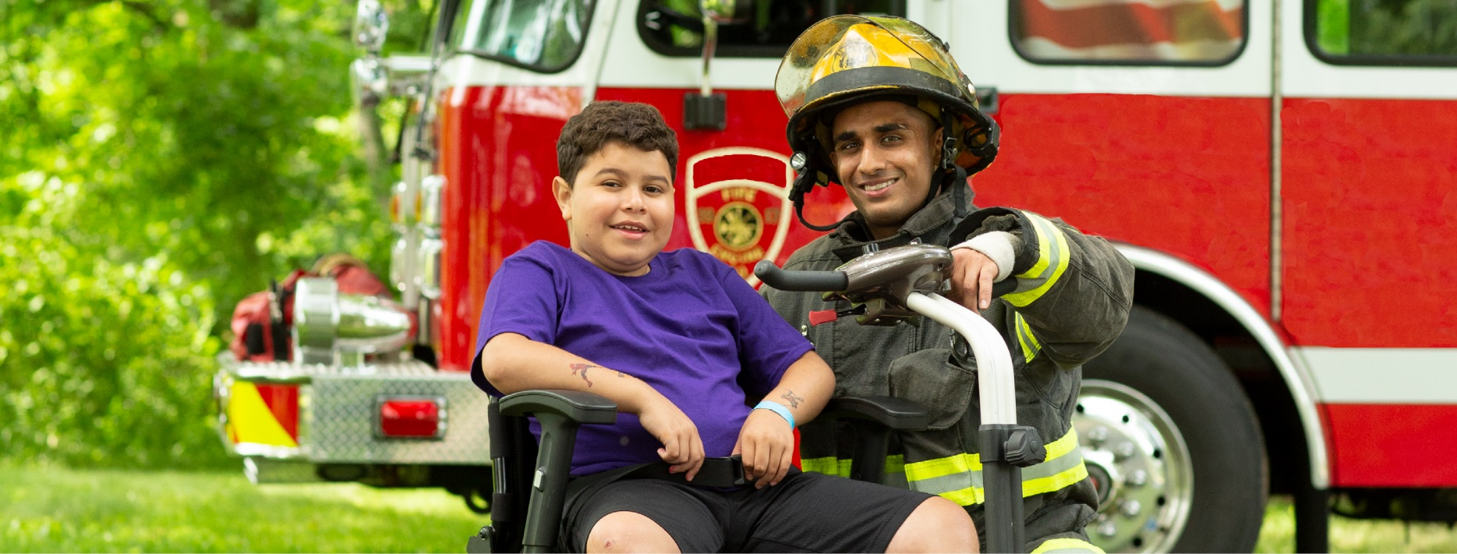
Local/Fire Department Name
Event Name/Type Sponsorship Opportunities

Showcase your corporate leadership with a connection to community heroes and leverage the long-standing partnership between MDA and fire fighters and to bring positive cause marketing benefits to your brand.

3rd Alarm Sponsor - $1,500 (smaller market) - $10,000 (larger market)
- MDA staff or fire fighter participation in one virtual company meeting or event
- opportunity to set up a table and provide give-away/product at event
- recognition as event sponsor and opportunity to speak during event program
- opportunity to hang company banner at event
- recognition on local/department social media channels
- opportunity for company to share involvement on social media

2nd Alarm Sponsor - $1,000 (smaller market) - $5,000 (larger market)
- opportunity to set up a table and provide give-away/product at event
- recognition as event sponsor during event program
- opportunity to hang company banner at event
- recognition on local/department social media channels
- opportunity for company to share involvement on social media

1st Alarm Sponsor - $500 (smaller market) - $2,500 (larger market)
- recognition as event sponsor during event program
- recognition on local/department social media channels
- opportunity for company to share involvement on social media
For Additional Information Contact
Name
xxx.xxx.xxxx
email

