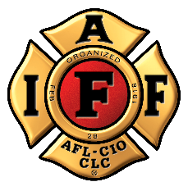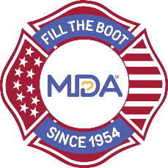
FOR IMMEDIATE RELEASE Contact: Contact Name
DATE Contact Email
Contact Phone

Help Rescue Professional Fire Fighters Association Local ##

CITY (ALL CAPS), State, Month Day, Year — The International Association of Fire Fighters (IAFF) has collected critical funds in the community since 1954 – one dollar at a time – as part of the Fill the Boot program. This year, due to local restrictions, it is not possible for Professional Fire Fighters Association Local ## members to Fill the Boot as they normally do, but they are kicking off a socially distanced Fill the Boot event to raise lifesaving funds to empower people living with neuromuscular disease to achieve their potential.

In lieu of conducting their traditional fundraiser, Professional Fire Fighters Association Local ## members are asking for your help to rescue them from the location rooftop on date. Fire fighters will camp out on the rooftop for x hours/days (rain or shine) to raise their goal of $xx,xxx.

We encourage the community to make donations online or deliver donations in person: https://filltheboot.donordrive.com/URL

The partnership between MDA and IAFF began in 1954 when the IAFF signed a proclamation designating MDA its charity of choice and vowing to continue raising awareness and funds until cures are found. To date, the partnership fundraising activities of over 300,000 fire fighters nationwide have raised more than $679 million over nearly seven decades. These funds have led in part to 14 new FDA-approved treatments for neuromuscular diseases and supported newborn screening in many states across the country for spinal muscular atrophy (SMA) and Pompe disease.

“We are forever grateful to IAFF for maintaining their strong commitment to the Fill the Boot program -- even during the pandemic!” said Donald S. Wood, PhD, President and CEO of MDA. “Without a doubt, much of the progress made in the field of neuromuscular disease research, care and advocacy, has been possible because of the decades of support and indefatigable efforts of the IAFF,” he continued.

The dollars raised through Fill the Boot funds the MDA’s work toward its mission of empowering people living with neuromuscular disease to achieve their potential. MDA works together with the IAFF to advance care​, accelerate research and advocacy​, and unite the community​.

Donate in-person or at https://filltheboot.donordrive.com/URL
Follow @MDAorg on Facebook, Instagram, Twitter
Follow the IAFF at Facebook.com/IAFFonline, twitter.com/@IAFFNewsDesk, Instagram.com/iaff1918

###

