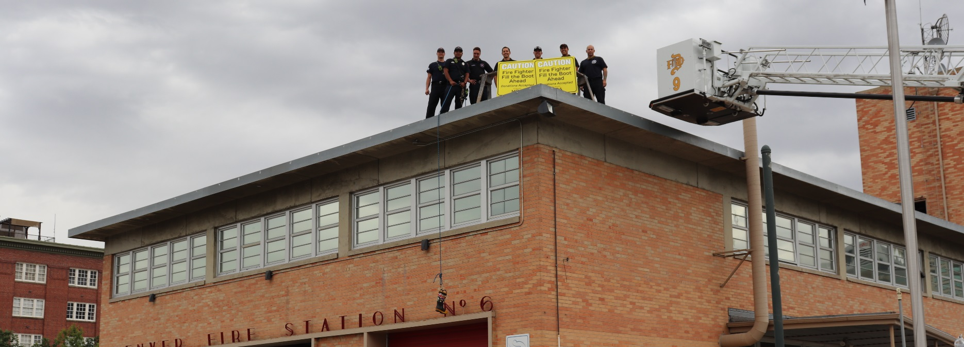

Local/Fire Department Name
Rooftop Rescue

Month Day, 20XX • Time

Location
Location Address

Help rescue Local/Fire Department Name from the rooftop of Location by donating to MDA

Fundraising Goal: $XX,XXX

Donate Today:
URL/QR CODE

For more information, or to get involved, please contact:
Name at XXX-XXX-XXXX or email

