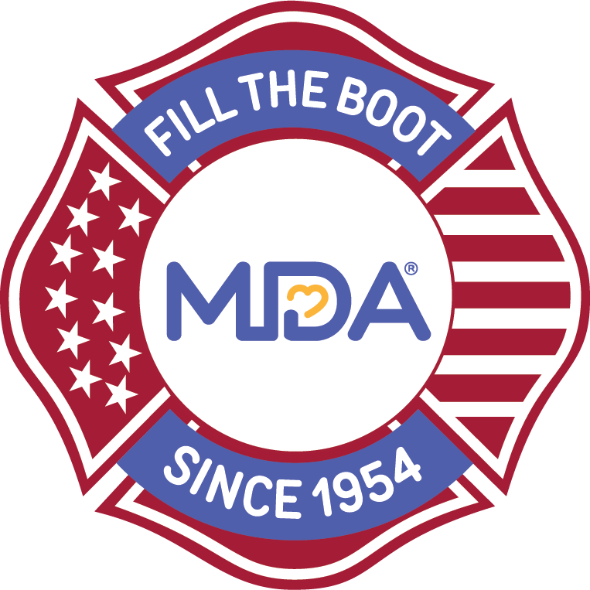MDA Fill the Boot®

2021 Radio Script Sample & Template

Many radio stations have 15-and 30-second slots for public service announcements (PSAs) that are often read on-air by the morning and afternoon drive-time hosts.

You can adjust the radio script templates below to fit your respective markets and email it to your contacts at local radio stations (typically the community relations or public service contact). Ask them if they can include it in their advertisement/announcement rotation for the days your Fill the Boot campaign is taking place.

[CITY] FILL THE BOOT IS [DATES]

TRAFFIC MAY BE A LITTLE SLOWER TODAY AT [MAJOR INTERSECTION], BUT IT’S FOR A GREAT CAUSE…members of [Name of Local or Department] are Filling the Boot for the Muscular Dystrophy Association through [end date]…

these funds will help TRANSFORM THE LIVES kids and adults in [city] with muscular dystrophy, als, and related NEUROMUSCULAR diseases.

please be generous and safe…going when the light turns green because donations will not be collected during green lightS.

call [local office number] for more information and thank you for your generosity…

(30 SECONDS)

###

[CITY] FILL THE BOOT IS [DATES]

at major intersections Throughout [city] fire fighters will be filling the boot for the muscular dystrophy association…

Please be safe and generous…donations help TRANSFORM THE LIVES kids and adults in [city] with muscular dystrophy, als and related NEUROMUSCULAR diseases.

(15 SECONDS)

###

SAMPLE script created for the Washington D.C market:
Listeners, TRAFFIC MAY BE A LITTLE SLOWER TODAy at McLearen Road and Centerville Road in Herndon, virginia... BUT IT’S FOR A GREAT CAUSE …

members of the Fairfax County fire department are Filling the Boot for the Muscular Dystrophy Association throughout Labor Day Weekend…

these funds will help TRANSFORM THE LIVES kids and adults in FAIRFAX COUNTY with muscular dystrophy, als and related MUSCLE-DEBILITATING diseases.

please be generous and safe…going when the light turns green because donations will not be collected during green lights…

look for Fire Fighters at major intersections and please be generous! Tuesdays’ traffic should be back to normal and thank you for your generosity…

Fill The Boot collections are also taking place at:
Centerville Road and Lee Highway in Fairfax
Nutley St. and Marshall Road
Franconia Rd. and South Van Dorn St
Rte 236 at John Marr
Rte 1 at Fordson Road
South Carlin Springs/Colombia Pitke
Leesburg Pike and Crossroads Center
Route 1 at Beddoo St
Walker Road and Georgetown Pike
Fashion Blvd and Route 7

###

