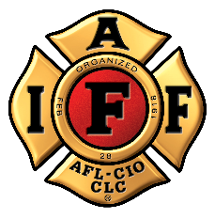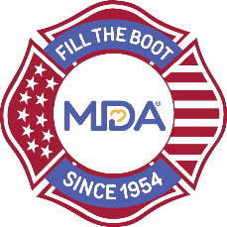
FOR IMMEDIATE RELEASE Contact: Contact Name
DATE Contact Email
Contact Phone

[Professional Fire Fighters Association Local ##] Launch 2021 Virtual Fill the Boot Fundraiser for the Muscular Dystrophy Association

[CITY (ALL CAPS)], [State], [Month] [Day], 2021 — For 67 years, the International Association of Fire Fighters (IAFF) has collected critical funds in the community – one dollar at a time – as part of the Fill the Boot program. [Professional Fire Fighters Association Local ##] will resume this long-standing tradition as its members kick off a virtual Fill the Boot program to raise lifesaving funds for scientific and clinical research and care for over 300,000 families nationwide living with muscular dystrophy, ALS, and over 40 related neuromuscular diseases.

Donate at https://filltheboot.donordrive.com/URL or by text ‘BOOT’ to 243-725

The partnership between MDA and IAFF spans 67 years, beginning in 1954 when the IAFF signed a proclamation designating MDA its charity of choice and vowing to continue raising awareness and funds until cures are found. To date, the partnership fundraising activities of over 300,000 fire fighters nationwide has raised $672 million over nearly seven decades. In the past six years, these funds have led in part to 12 new FDA-approved treatments for neuromuscular diseases and supported newborn screening in many states across the country for spinal muscular atrophy (SMA) and Pompe disease.

“For over 67 years, IAFF fire fighters have been resolute in our commitment to supporting MDA families. In 2021, we recommit to those families, as we return to our communities across the nation to Fill the Boot for MDA,” said Roger Lopez IAFF/MDA National Coordinator.

“We are forever grateful to IAFF for maintaining their strong commitment to the Fill the Boot program -- even during the pandemic!” said Donald S. Wood, PhD, President and CEO of MDA. “Without a doubt, much of the progress made in the field of neuromuscular disease research, care and advocacy, has been possible because of the decades of support and indefatigable efforts of the IAFF,” he continued.

The dollars raised through the Fill the Boot campaign funds the Muscular Dystrophy Association’s work toward its mission of transforming the lives of individuals with neuromuscular disease through innovations in research and care.

Follow @MDAorg on Facebook, Instagram, Twitter

Follow the IAFF at Facebook.com/IAFFonline, twitter.com/@IAFFNewsDesk, Instagram.com/iaff1918

# # #

