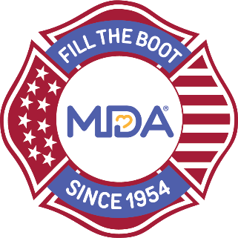

Date

Dear Company,

Every day, kids and adults are diagnosed with muscular dystrophy, ALS and related neuromuscular diseases that take away their ability to walk, run, hug, dress themselves, talk and even breathe. There are currently only a few treatments and no cures.

For more than 65 years, the Muscular Dystrophy Association (MDA) and the International Association of Fire Fighters (IAFF) have been working together to transform the lives of people affected by these diseases through the honored tradition of Fill the Boot. Each year, through MDA’s Fill the Boot program, more than 100,000 dedicated fire fighters stand at store fronts and intersections across the country asking pedestrians, motorists, customers, and other passersby to donate to MDA, helping them fill their boot with contributions.

We would like to invite you to support the city/town fire fighters in this long-standing tradition by allowing them to collect in front of your store on dates.

MDA is a national volunteer health agency committed to transforming the lives of people affected by muscular dystrophy, ALS and related neuromuscular diseases. Your partnership will directly impact innovations in science and accelerate the delivery of treatments and cures as well as provide innovations in care so that families living with these diseases get the support they need. MDA is a 501 (c)(3) agency (Tax ID # 13-1665552).

Thank you again for considering our request. Please contact me if you have any questions or would like additional details. I look forward to you helping us support the fire fighters in their quest to find a cure for neuromuscular disease.

Sincerely,

Fire Fighter Name
Title
Contact Info

