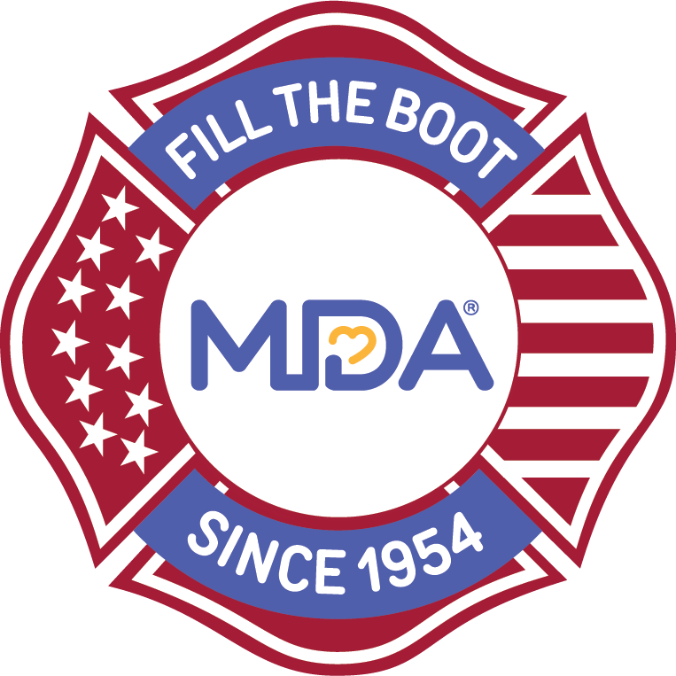

**[Local/Fire Department Name/Logo]**

**1st Annual Fire Engine Pull**

**[Day, Month, 20XX] • [Time] [Location]**

**Team Entry Form**

Thank you for entering your team into the 1st Annual Fire Engine Pull for MDA! All funds collected through the event benefit the Muscular Dystrophy Association and support efforts to help transform the lives of kids and adults with muscular dystrophy, ALS and related neuromuscular diseases.

Team Captain Name:_________________________________________________________________________

Team Name:________________________________________________________________________________

Phone:____________________________________Email:____________________________________________

Address:___________________________________________________________________________________

 City:_________________________________________________State:________________ZIP:______________

[$Insert Entry Fee] Be sure to register your team at: Insert Fire Engine Pull URL

**Please return completed form and entry fee no later than [Day, Month, 20XX].**

[Local/Fire Department Contact Information]

**Muscular Dystrophy Association • mda.org**

Team Entry Form

Thank you for entering your team into the [Local/FD Name] 1st Annual Fire Truck Pull for MDA!

All funds collected through the event benefit the Muscular Dystrophy Association and support efforts to help transform the lives of kids and adults with muscular dystrophy, ALS and related muscle-debilitating diseases.