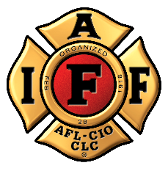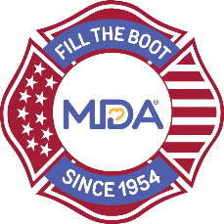
FOR IMMEDIATE RELEASE

Contact:
Contact Name
Contact Email
Contact Phone

Professional Fire Fighters Association Local ## Support Muscular Dystrophy Association with Annual Fill the Boot Drive

CITY (ALL CAPS), State, Month Day, Year — The International Association of Fire Fighters (IAFF) has collected critical funds in the community since 1954 – one dollar at a time – as part of the Fill the Boot program for the Muscular Dystrophy Association (MDA). The Professional Fire Fighters Association Local ## will be continuing this long-standing tradition as its members kick off the annual program raising funds to support MDA’s vision to accelerate research, advance care, and advocate for the support of MDA families.

Dedicated fire fighters from Professional Fire Fighters Association Local ## will hit the streets or storefronts with boots in hand asking pedestrians, motorists, customers, and other passersby to donate to MDA on Dates at Time, at FTB location(s).

Individuals and local businesses can also support the fire fighters by donating online at: https://filltheboot.donordrive.com/URL

The partnership between MDA and IAFF began in 1954 when the IAFF signed a proclamation designating MDA its charity of choice and vowing to continue raising awareness and funds until cures are found. To date, the nearly seven-decade partnership has raised more than $679 million with involvement from over 300,000 fire fighters nationwide. These funds have led in part to over a dozen FDA-approved drugs in as many years for those with neuromuscular disease. Those treatments were created from MDA’s vision to open a new field of medicine and push the boundaries of the medical frontier we call genetic medicine.

“What the IAFF has done for MDA over the past 68 years is unprecedented,” said Donald S. Wood, Ph.D., President and CEO of MDA. “With the support from our partners at the IAFF, MDA is doing the impossible in accelerating research, advancing care, and advocating for people living with neuromuscular disease. We have a mission to empower the people we serve to life longer, more independent lives and we will fulfill this mission together, with the IAFF.”

About the IAFF
The International Association of Fire Fighters represents more than 326,000 professional fire fighters and paramedics who protect more than 85% of the nation's population. More than 3,500 affiliates and their members protect communities in every state in the United States and in Canada. To learn more visit IAFF.org and follow the IAFF at Facebook, Twitter, and Instagram.

About Muscular Dystrophy Association
Muscular Dystrophy Association (MDA) is the #1 voluntary health organization in the United States for people living with muscular dystrophy, ALS, and related neuromuscular diseases. For over 70 years, MDA has led the way in accelerating research, advancing care, and advocating for the support of our families. MDA’s mission is to empower the people we serve to live longer, more independent lives. To learn more visit mda.org and follow MDA on Instagram, Facebook, Twitter, TikTok, and LinkedIn.
###

